# Kennesaw State University

College of Computing and Software Engineering

Department of Computer Science

CS 5070, Mathematical Structures for Computer Science, Section W01

Assignment #1

Amrit Singh, [asingh59@students.kennesaw.edu](mailto:asingh59@students.kennesaw.edu)

06/05/2025

## Problem Statement

Problem of this document is to solve the following problem set for assignment #1.

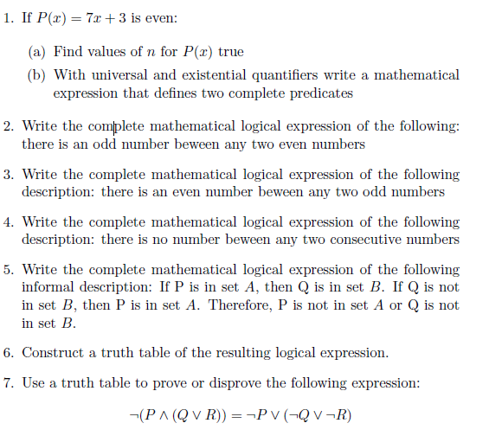

## Summary / Purpose

Purpose of this document is to provide solutions to the problem set outlined in the Problem Statement section.

## Solutions

1. If P(x) = 7x + 3 is even:
   1. Find values of n for P(x) true

If *P(x)* = 7*x* + 3 is even, then there is some set of n such that it makes this predicate even. Consider the following:

P(-3) = 7(-3) + 3 = -18 which is even

P(-2) = 7(-2) + 3 = -11 which is odd

P(-1) = 7(-1) + 3 = 4 which is even

P(0) = 7(0) + 3 = 3 which is odd

P(1) = 7(1) + 3 = 10 which is even

P(2) = 7(2) + 3 = 17 which is odd

P(3) = 7(3) + 3 = 24 which is even

P(4) = 7(4) + 3 = 31 which is odd

P(5) = 7(5) + 3 = 38 which is even

….

P(2n - 1) = 7(2n - 1) + 3 = 14n - 4 which is even

P(2n) = 7(2n) + 3 = 14n + 3 which is odd

Therefore, for all odd n in the integer set, we find an x such that x = 2n - 1 where *P(x)* = 7*x* + 3 is even.

* 1. With universal and existential quantifiers, write a mathematical expression that defines two complete predicates.

Considering what we’ve learned above, we can denote that there is a set A where there exists some n in the integer set such that 2n + 1 and there exists x in the integer set such that 7x + 3. This can be denoted as the following predicates:

P(x) = 7x + 3 = is even = 2n

Q(X) = x = is odd = 2n - 1

Which can be written as the following mathematical expression:

A = { ∀x ∈ Z : ∃n ∈ Z (7x + 3 = 2n ) ∧ (x = 2n - 1) }

1. Write the complete mathematical logical expression of the following:

There is an odd number between any two even numbers

This can be written as: between any two even numbers, there is an odd number.

A = {∀x∈Z ∀y∈Z ∀z∈Z: ∃n∈N ((x = 2n) ∧ (y = 2n) ∧ (z = 2n -1) ^ (x < z < y))}

For all x and y integers, there exists some number n, an element of natural numbers, and there exists some number z, an element of natural numbers, where x is even, y is even, z is odd, and x < z < y.

1. Write the complete mathematical logical expression of the following description:

There is an even number between any two odd numbers

This description can be written as between any two odd numbers, there is an even number.

A = {∀x∈Z ∀y∈Z ∀z∈Z: ∃n∈N ((x = 2n - 1) ∧ (y = 2n - 1) ∧ (z = 2n) ∧ (x < z < y))}

For all x and y integers, there exists some number n, an element of natural numbers, and there exists some number z, an element of natural numbers, where x is odd, y is odd, z is even, and x < z < y.

1. Write the complete mathematical logical expression of the following description:

There is no number between any two consecutive numbers

This description can also be written as between any two consecutive numbers, there is no number.

A = {∀x∈Z: ¬(∃n ∈ Z, (x < n < x + 1))}

which is equivalent to….

A = {∀x∈Z: (∀n ∈ Z, ¬ (x < n < x + 1)}

For all x, an element of integers, such that for all z integers there is not a z that is less than x and greater than x +1.

1. Write the complete mathematical logical expression of the following informal description:

If P is in set *A*, then Q is in set *B*.

If Q is not in set *B*, then P is in set *A*.

Therefore, P is not in set *A* or Q is not in set *B*.

These three statements mean the following:

P ∈ A → Q ∈ B

￢(Q ∈ B) → P ∈ A

Therefore, ￢(P ∈ A) ∨ ￢(Q ∈ B)

The complete mathematical expression is then:

Let R = P ∈ A

Let S = Q ∈ B

((R → S) ∧ (￢S →R)) → (￢R ∨ ￢S)

1. Construct a truth table of the resulting logical expression.

|  |  |  |  |  |  |  |  |  |
| --- | --- | --- | --- | --- | --- | --- | --- | --- |
| R | S | R → S | ￢R | ￢S | ￢S →R | (R → S) ∧  (￢S →R) | ￢R ∨ ￢S | ((R → S) ∧ (￢S →R)) → (￢R ∨ ￢S) |
| T | T | T | F | F | T | T | F | F |
| T | F | F | F | T | T | F | T | T |
| F | T | T | T | F | T | T | T | T |
| F | F | T | T | T | F | F | T | T |

1. Use a truth table to prove or disprove the following expression:

￢(P ∧ (Q ∨ R)) = ￢P ∨ (￢Q ∨ ￢R)

|  |  |  |  |  |  |  |  |
| --- | --- | --- | --- | --- | --- | --- | --- |
| P | Q | R | ￢P | ￢Q | ￢R | Q ∨ R | ￢(P ∧ (Q ∨ R)) |
| T | T | T | F | F | F | T | F |
| T | T | F | F | F | T | T | F |
| T | F | T | F | T | F | T | F |
| T | F | F | F | T | T | F | T |
| F | T | T | T | F | F | T | T |
| F | F | T | T | T | F | T | T |
| F | T | F | T | F | T | T | T |
| F | F | F | T | T | T | F | T |

|  |  |
| --- | --- |
| (￢Q ∨ ￢R) | ￢P ∨ (￢Q ∨ ￢R) |
| F | F |
| T | T |
| T | T |
| T | T |
| F | T |
| T | T |
| T | T |
| T | T |

Using the truth table above, we can disprove the expression above because it is not equal in two cases, one where P = True, Q = True, R = False and two where P = True, Q = False, and R = True.

## References

[1] Garrido, J. (2021, August 14). *CS5070 Mathematical Structures for Computer Science - Notes 1* [Slide show; Powerpoint]. D2L. https://kennesaw.view.usg.edu/d2l/le/content/3550928/viewContent/55786708/View?ou=3550928

[2] Garrido, J. (2022, May). *CS5070 Mathematical Structures for Computer Science - Additional notes* [Slide show; Powerpoint]. D2L. https://kennesaw.view.usg.edu/d2l/le/content/3550928/viewContent/55786706/View

[3] Kennesaw State University, College of Computing and Software Engineering, Department of Computer Science, Mathematical Structures for Computer Science. (n.d.). CS5070 Assignment 1. In *https://kennesaw.view.usg.edu/d2l/le/content/3550928/viewContent/55786667/View*.

[4] Levin, O. (2016). *Discrete mathematics: An Open Introduction*.